**1.INTRODUCTION**

**1.1. OVERVIEW**

Water is the key to the life. Without water no life can survive on earth. Conservation of surface water and rain water harvesting is becoming the most important duty of every human being.

On Earth, water is becoming a scarce resource. The water is decreasing day by day. Water scarcity is the lack of sufficient available water resources to meet water needs within a region. Water scarcity involves water shortage, water stress or deficits, and water crisis. The relatively new concepts of water stress is difficulty in obtaining sources of fresh water for use during a period of time it may result in further depletion and deterioration of available water resources .According to the United Nations Development Program[1],the latter is found more often to be the cause of countries or regions experiencing water scarcity, as most countries have enough water to meet household, agricultural and environmental needs, but lack the means to provide it in an accessible manner. Now the awareness for the water conservation has reached its peak, so it’s the time for a change.

Water conservation starts at every home. So we are introducing a system as our mini project to conserve the water by solving the basic water wastage problems and rainwater harvesting.

We are focusing on the water wastage situations like overflow in main tank, overflow from taps and leakage in pipeline.

The system also includes automatic irrigation and rain water harvesting by basic elimination of chemically polluted water.

**1.2. WHO NEED IT AND WHY**

The users of our project is every single man in the world who live in urban societies and socially living communities. Since water is a high valued resource everyone has to be under our Intelligent Water Management System to save it.

The reason why people need is simple that everybody need water for living if we don’t start to save it now it will be too late. Everyone knows these facts so they need a simple system for this purpose our system will do this work.

**2. LITERATURE SURVEY**

**2.1. MARKET RESEARCH**

Market is very big place. Every day 100’s of products is introduced in the market. So the competition is tough for a product to stays in the market it has to be unique from other similar systems in the market. Since water conservation became a very important subject there is many systems in the market to serve this purpose.

**2.1.1. AVAILABLE SIMILAR SYSTEMS AND COMPARISON**

In this project we are introducing 6 different techniques of water management. There is no commercial system which covers all these. Let’s consider it by parts.

**2.1.1.a DIVIDING WATER EQUALLY**:

This system is not available right now it is a future technology in future every society will have this system.

**2.1.1.b WATER LEAKAGE DETECTION AND CONTROL**:

Since these problems are common everywhere there are many such products in the market. Some of them are

**i. FlowLogic**

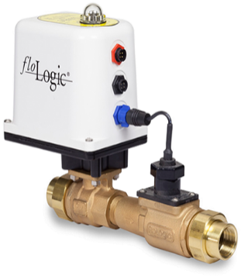

Fig 2.1 FlowLogic

Manufactured in the USA, a FloLogic system is flexible, reliable, and customizable and will interface with any residential or building security system to alert you when a leak is detected while providing your home with the safeguard of emergency water shut off. [2]

ii. **LeakSMART**

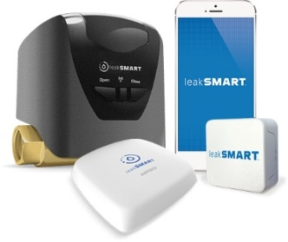

Fig 2.2 LeakSMART

LeakSmart stops water damage before it starts. The system not only detects water leaks throughout your home, but also shuts off the water in less than 5 seconds when a leak is detected. Plus, it alerts you when detecting water leaks with audible and visible alarms, as well as smart device app notifications. [3]

**iii. WATERGUARD**

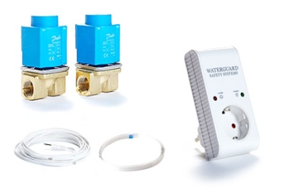

Fig 2.3 Waterguard

The Waterguard Home system protects property by timing the water flowing through pipes. Each time when stop running the water, the time is reset to zero. The user sets the maximum time of continuous water flow allowed when the property is occupied. This is known as Low Guard and ranges from 1 – 40 minutes. And the same for when the property is unoccupied, known as High Guard which ranges from 0.1 – 5 minutes. If the maximum time is exceeded on either guard level, the stop valve is automatically activated to shut off the water supply, protecting property from the damage caused by burst and leaking pies [4].

**iv. FLOOD MASTER**

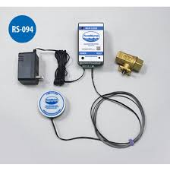

Fig 2.4 Flood master

Flood Master offers a full range of dependable systems that automatically shut off the water supply when a leak is detected in home or business.

It is being used to stop leaky drains, dishwashers, washing machines, hot water heaters, sump pumps, tubs, condensate systems, sinks and water mains from causing expensive property damage [5] .

All these systems use flow speed or moisture detectors but in here we use difference in amount of water used in the main line and sub lines. So we can track leakage anywhere.

**2.1.1.c WATER OVERFLOW DETECTION AND CONTROL**

In survey, we realized that for overflow many systems use water sensors. Which reads whenever water is present. So it will need AI to detect the fair usage and overflow. So by reading the water directly coming from tank and by user response switch our system is unique.

**2.1.1.d WATER TANK LEVEL CONTROL**:

There is 100’s of devices for this purpose even in Kerala V-guard producing it [ 6]. Since it is a simple it is very common. There are many advance systems for this purpose like ultrasonic method but we use transistors for make system cheaper.

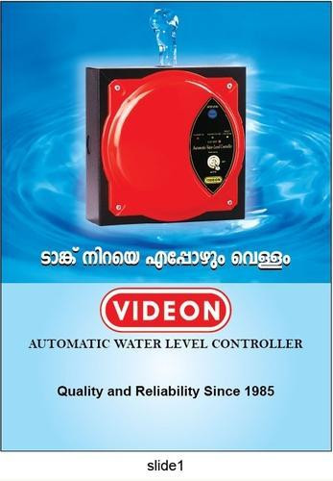

Fig2.5 V-guard

**2.1.1.e AUTOMATIC IRRIGATION**:

Here the irrigation is based on time and rain. There are many advanced systems that user moisture of soil for irrigation triggering. In future we can calculate moisture instead of time and rain.

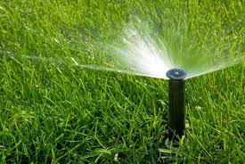

Fig 2.6 Irrigation

**2.1.1.f RAIN WATER HARVESTING**:

Rain water harvesting is common everywhere. But in our system we use valve to store to store water by eliminating the chemically polluted water. So our system is new.

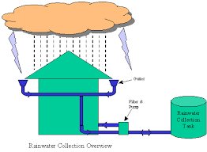

Fig 2.7 Rain water harvesting

**3. SYSTEM OVERVIEW**

**3.1. Block Diagram**

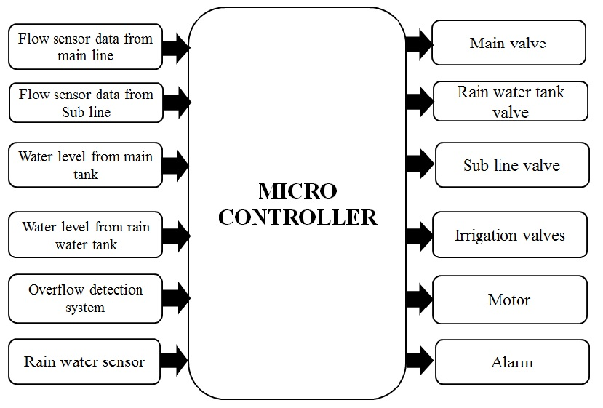

Fig 3.1 Block Diagram

**3.2. WORKING**

The project can be divided in to 6 parts

**3.2.1. DIVIDING WATER EQUALLY**.

Sub line flow sensor is used for this purpose when the sub flow sensor reading exceeds the daily limit the sub line valve gets closed. The reset button has to be pushed to open the valve

**3.2.2**. **WATER LEAKAGE DETECTION AND CONTROL**

Here the two flow sensor are used. If there is a leakage, there will be difference in between main flow sensor and sub line flow sensor then the first LED gets on and the sub valve will be closed if there is still reading the leakage is in main line then main valve will be closed with activating the buzzer

**3.2.3**. **WATER OVERFLOW DETECTION AND CONTROL**

. There is a positive voltage provided in the main tank this voltage can be experienced throughout pipeline if an overflow occurs the water goes to the drain the base of the transistor is connected in the drain then the amount of water flowing is calculated if it exceeds the limit the buzzer will get activated. There is a response switch in the place if the user does not press it the subline valve will be shutoff else the buzzer will be stop and valve will not close.

**3.2.4**. **WATER STORAGE MAINTAINING**

The two main tank water levels are used here they are used to indicate the higher and lower level of the water level in the tank. When the water level is low the motor gets on and when it is full the motor gets off.

**3.2.5. AUTOMATIC IRRIGATION SYSTEM**

Here the two irrigation valves and rain tank water level indicator is used. At a particular time when that day if there is no rain the crops get irrigated. If there is sufficient water in the rain water tank the rain water tank irrigation valve will be open else the main tank irrigation valve.

**3.2.6. RAIN WATER HARVESTING**

The rain water sensor is used to detect the rain if there is rain after some time the valve to store water gets open because the first water is chemically polluted. This delay will be more for first rain. If no rain valve remains closed to prevent pollution of water

**4. SYSTEM IMPLEMENTATION**

**4.1 HARDWARE SECTION**

**4.1.1 CIRCUIT DIAGRAM**

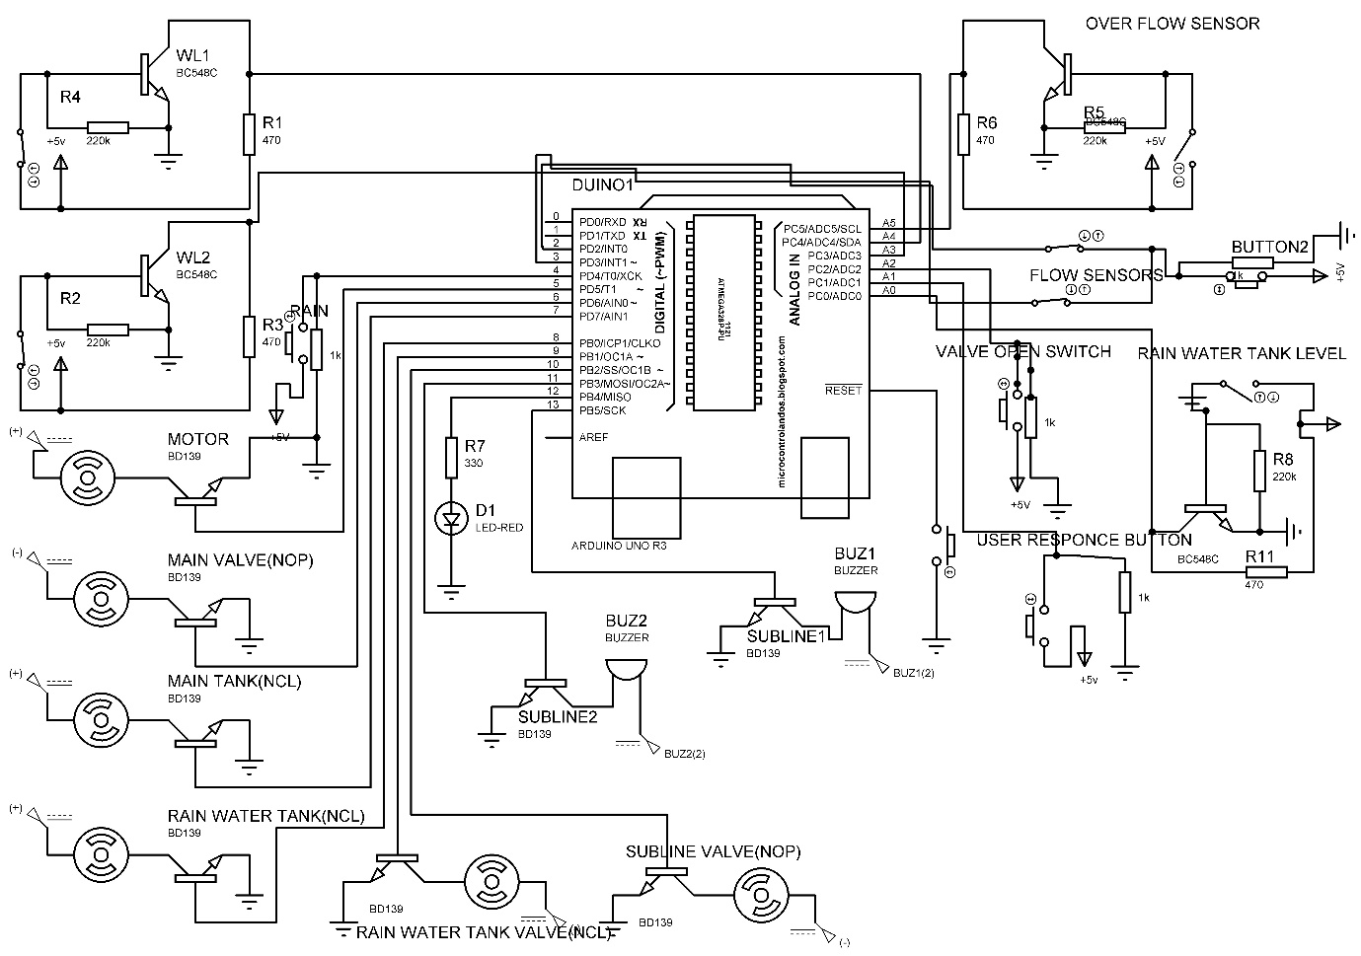

Fig 4.1 Circuit Diagram

**4.1.2. CIRCUIT DESCRIPTION**

* The circuit consist of mainly 8 components

**4.1.2.a. ARDUINO PRO MINI**

It is the brain of this system. The Arduino Pro Mini is a microcontroller board based on the ATmega328.  It has 14 digital input/output pins (of which 6 can be used as PWM outputs), 6 analog inputs, an on-board resonator, a reset button, and holes for mounting pin headers. A six pin header can be connected to an FTDI cable or Spark fun breakout board to provide USB power and communication to the board. The Arduino Pro Mini is intended for semi-permanent installation in objects or exhibitions.

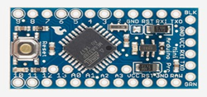

Fig 4.2 Arduino Pro Mini

The board comes without pre-mounted headers, allowing the use of various types of connectors or direct soldering of wires. The pin layout is compatible with the Arduino Mini. There are two version of the Pro Mini. One runs at 3.3V and 8 MHz, the other at 5V and 16 MHz. Here we use 5v and 16 MHz.

**4.1.2.b. WATER LEVEL INDICATING AND OVERFLOW CIRCUIT**.

There are 3 water level indicators in the circuits 2 in the main water tank and 1 in rain water tank. There is also overflow part which uses this circuit. The circuit consist of 1 NPN transistor and two resistors.

It is working on the principle of transistor switching. The base of the transistor is connected in the water also there will be positive voltage in the water. If the base is connected to this source via water the collector voltage of the transistor goes low this is read in the processor as water level.

The main tank water level indicators are connected to digital pin A3 and A4 of microprocessor respectively and rain water tank level is connected to analog input pin A0 and overflow indicator is connected to analog input pin A5. The transistor used here is BC 548C see fig 4.3

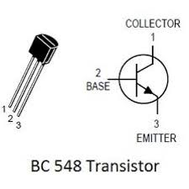

Fig 4.3 BC 548

**4.1.2.c. SOLENOID VALVE**

The solenoid valves are valves which can be open and close by using dv voltage here we use 24 v solenoid valve. Solenoid valve works by the principle of electromagnetic induction [2]. When the valve is energized the solenoid coil in the valve become a strong electro magnet which pulls up a shutter in the valve that makes the valve open .The working voltage of the solenoid valve is 24 v which can’t get from Arduino pro mini so we use a transistor BD 139 for driving the valve the base of the transistor is connected to digital pin of pro mini. The load is connected to the collector with 24 v supply and the emitter is grounded the valve is shown in fig 4.4

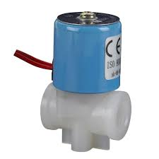

Fig 4.4 Solenoid valve

**4.1.2.d DC PUMP**

The DC pump is a motor. In this circuit the DC pump is connected to digital pin 5 that is driven by transistor BD 139 that is used to fill the tank

In this mini project we use 12v dc pump which can be replaced by electric motor in practical application

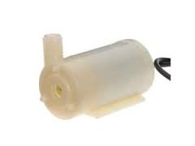

Fig 4.5 DC pump

**4.1.2.e RAIN WATER SENSOR**

Rain water sensor is used to detect the rain. It is simply a pcb board with copper stripes it is connected to the digital pin 4 of the microcontroller When water falls on the pcb it causes the copper stripes to connect and it can be read in micro controller as rain indicator.

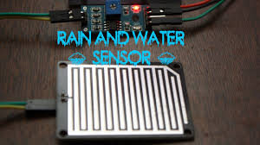

Fig 4.6 Rain sensor

**4.1.2.f. FLOW SENSORS**

Flow sensors are sensors which are used to find the amount of water used in the system it is actually a hole sensor with a turbine when water flows the turbine gets rotated by hole sensor the no of rotation can be calculated hence water usage can be calculated.

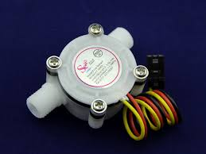

Fig 4.7 Flow sensor

**4.1.2.g. INDICATORS**

**i. BUZZER**

Buzzer is an electronic device commonly used to produce sound light weight, simple construction and low price make it usable in various application like car/truck reversing indicator, computers, computers, call bell etc. Buzzer is based on the inverse principle of piezo electricity. It is the phenomenon of generating electricity when mechanical pressure is applied to certain materials and the vice versa is also true. materials are called piezoelectric materials. Piezo electric material is either naturally available or manmade. piezo ceramic is class of manmade material, which poses piezo electric effect and is widely used to make disc, the heart of piezo buzzer. when subjected to an alternating electric field they stretch or compress in accordance with the frequency of the signal thereby producing sound.

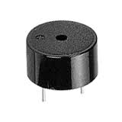

Fig 4.8 Buzzer

ii. **LED**

A light emitting diode is a semiconductor diode that emits light when an electrical current is applied in the forward direction of the devices, as in the simple LED circuit. The effect is a form of electroluminescence where incoherent and narrow spectrum light is emitted from the p-n junction. LEDs are widely used as indicator lights on electronic devices and increasingly in higher power applications such as flashlights and area lighting. An LED is usually a small area light source, often with optics added to chip to shape it radiations pattern and assist in reflection.

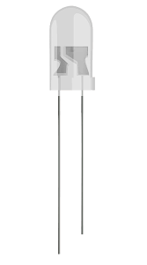

Fig 4.9 LED

The colour of emitted light depends on the composition and the condition of semiconductor materials used, and can be infrared, visible, or UV besides lighting, interesting applications can include using UV LEDs for sterilization of water and disinfection of devices, and as a grow light to enhance photosynthesis in plants.

**4.1.2.h. PUSH BUTTONS**

The push buttons are used for resetting the valves and for user response to the overflows. It is a simple push to activate switch.

The button to reset the valves is connected to analog read pin A2 and user response button is connected to A1

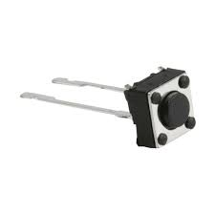

Fig 4.10 Push button

**4.1.2.i. IC LM 7805 AND IC LM 7812**

7805 and 7812 voltage regulated integrated circuit. They are member of 78xx series fixed linear regulated ICs. The voltage source in a circuit may have fluctuations and would not give the fixed voltage output. the voltage regulator IC maintain the output voltage at a constant value. the xx in 78xx indicates the fixed output voltage it is designed to provide. 7805 provides +5v regulated power supply. 7812 provides +12v regulated power supply. The 78xx voltage regulators employ built – in current limiting, thermal shut down, and safe –operating area protection which make them virtually immune to damage from output overload.7805 is a three-terminal positive voltage regulator like 7812.

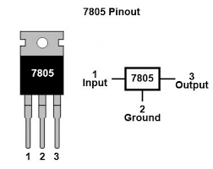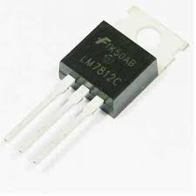

Fig 4.11 7805 and 7812

**4.1.2.j. BD 139**

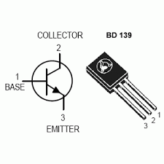

Fig 4.12 BD 139

BD 139 is an NPN transistor. It can manage high current loads up to 1.5 A. Arduino can only drive loads of 5 v and 400 Ma. We can’t drive high voltage or high current loads directly from Arduino so we use the BD 139. The load is connected to the collector of the BD 139

with the positive terminal of the voltage needed to drive load (i.e. up to 50v). The emitter of the transistor must be grounded to Arduino and the negative of voltage is also connected to the emitter.

The base is connected to the digital pins of Arduino. Its working is based on the transistor switching when the base of the transistor gets high by the output from Arduino the switching action occurs and transistor acts as a closed circuit then the load gets ON. If the Arduino output to pin is low the transistor acts as a closed switch, then the load gets OFF.

**4.1.3 PCB FABRICATION PROCESS**

A PCB is used to connect electronic components electrically. This is done by making conductive path ways for circuit connections by etching tracks from copper sheet laminated onto a non-conductive substrate.

A PCB consists of a conducting layer that is made up of thin copper foil. The insulating layer di-electric is laminated together with epoxy resin prepreg. The most commonly used PCB type is the FR-4. Boards may be single sided or double sided. Double sided PCB can be used to connect electronic components on both sides through through-hole plating. This is done by copper plating the walls of each hole so as to connect the conductive layers of the PCB.

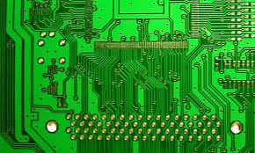

Fig 4.13 PCB

**ADVANTAGES OF PCB OVER BREAD-BOARD**

1. You can get a much higher density board with PCB.
2. You will find the PCB design to be more reliable than the one made on a bread board. The circuit will look neat without any wires popped up and will not fall apart.
3. You can have very precise control over the circuit component you are using, and you can comfortably fit in odd shaped components that are difficult to fix on a bread board.
4. For production of large volume of circuit boards, the costs become less and the soldering can be done by fully automated machines.

**4.2. SOFTWARE SECTION**

**4.2.1. FLOW CHART**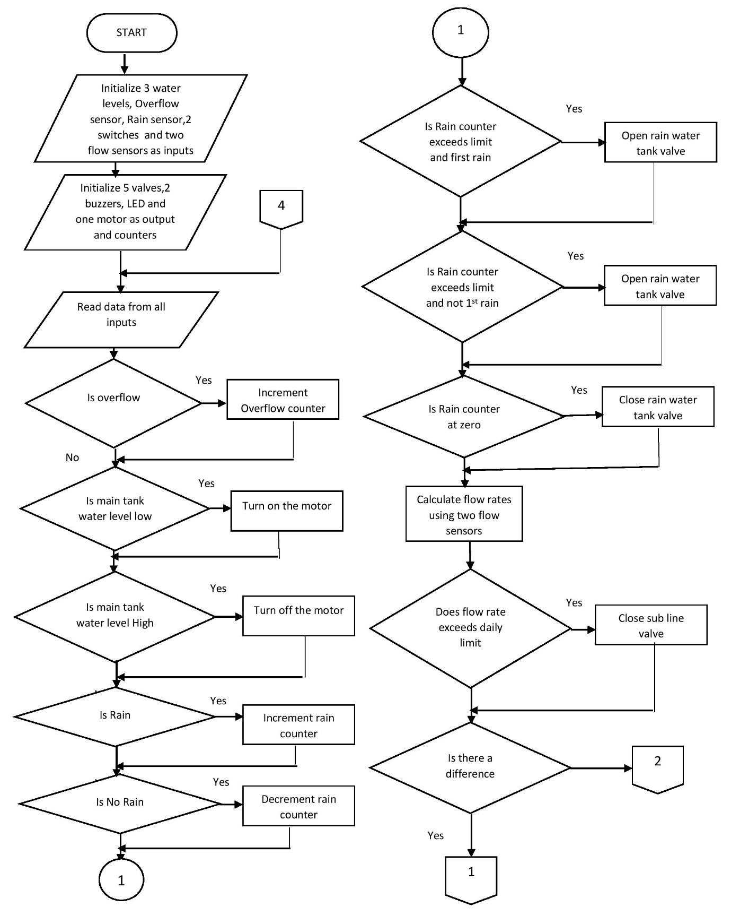

**NO**

**NO**

**NO**

**NO**

**NO**

**NO**

**NO**

**NO**

**NO**

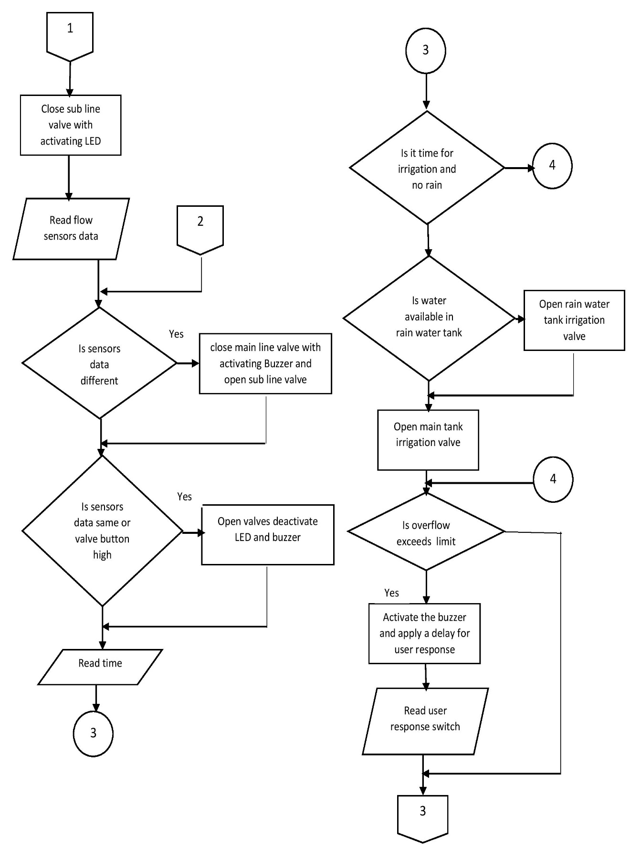

**NO**

**NO**

**NO**

**NO**

**YES**

**YES**

**NO**

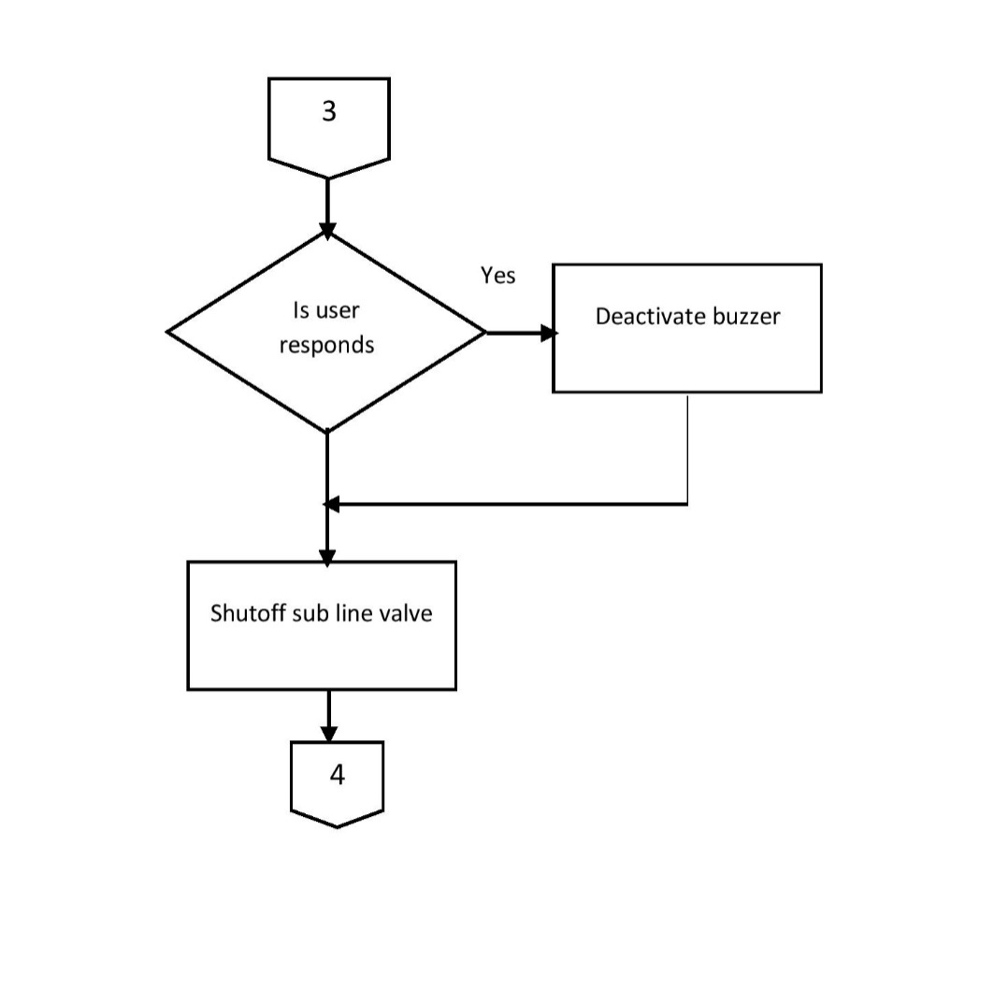

**NO**

Fig 4.14 Flow chart

**4.2.2. PROGRAMING TOOLS**

There are mainly two software’s used in this project

1.Proteus 8

2.Arduino IDE

**4.2.2.a. PROTEUS 8**



Fig 4.15 Proteus

The Proteus Design Suite is an Electronic Design Automation (EDA) tool including schematic capture, simulation and PCB Layout modules. It is developed in Yorkshire, England by Labcenter Electronics Ltd with offices in North America and several overseas sales channels. The software runs on the Windows operating system and is available in English, French, Spanish and Chinese languages [7].

The Proteus Design Suite is a Windows application for schematic capture, simulation, and PCB layout design. It can be purchased in many configurations, depending on the size of designs being produced and the requirements for microcontroller simulation. All PCB Design products include an auto router and basic mixed mode SPICE simulation capabilities.

### SCHEMATIC CAPTURE

Schematic capture in the Proteus Design Suite is used for both the simulation of designs and as the design phase of a PCB layout project. It is therefore a core component and is included with all product configurations.

### MICROCONTROLLER SIMULATION

The micro-controller simulation in Proteus works by applying either a hex file or a debug file to the microcontroller part on the schematic. It is then co-simulated along with any analog and digital electronics connected to it. This enables it's used in a broad spectrum of project prototyping in areas such as motor control, temperature control and user interface design. It also finds use in the general hobbyist community and, since no hardware is required, is convenient to use as a training or teaching tool Support is available for co-simulation of:

* Microchip Technologies PIC10, PIC12, PIC16, PIC18, PIC24, dsPIC33 Microcontrollers.
* Atmel AVR (and Arduino), 8051 and ARM Cortex-M3 Microcontrollers
* NXP 8051, ARM7, ARM Cortex-M0 and ARM Cortex-M3 Microcontrollers.
* Texas Instruments MSP430, PICCOLO DSP and ARM Cortex-M3 Microcontrollers.
* Parallax Basic Stamp, Freescale HC11, 8086 Microcontrollers.

### PCB DESIGN

The PCB Layout module is automatically given connectivity information in the form of a netlist from the schematic capture module. It applies this information, together with the user specified design rules and various design automation tools, to assist with error free board design. Design Rule Checking does not include high speed design constraints.PCB's of up to 16 copper layers can be produced with design size limited by product configuration.

### 3D VERIFICATION

The 3D Viewer module allows the board under development to be viewed in 3D together with a semi-transparent height plane that represents the boards enclosure. STEP output can then be used to transfer to mechanical CAD software such as Solidworks or Autodesk for accurate mounting and positioning of the board.

**4.2.2.b. ARDUINO IDE**



Fig 4.16 Arduino IDE

The Arduino Integrated Development Environment - or Arduino Software (IDE) - contains a text editor for writing code, a message area, a text console, a toolbar with buttons for common functions and a series of menus. It connects to the Arduino and Genuino hardware to upload programs and communicate with them [8].

Programs written using Arduino Software (IDE) are called **sketches**. These sketches are written in the text editor and are saved with the file extension. ino. The editor has features for cutting/pasting and for searching/replacing text. The message area gives feedback while saving and exporting and also displays errors. The console displays text output by the Arduino Software (IDE), including complete error messages and other information. The bottom right-hand corner of the window displays the configured board and serial port. The toolbar buttons allow you to verify and upload programs, create, open, and save sketches, and open the serial monitor.

The open-source **Arduino** Software (**IDE**) makes it easy to write code and upload it to the board. It runs on Windows, Mac OS X, and Linux. The environment is written in Java and based on Processing and other open-source software.

**5. APPLICATIONS**

The application of IWMS (Intelligent Water Management System) is vast it can be used in places where people living in as a community.

They include

1. Apartment buildings
2. Hospitals
3. Schools
4. Collages
5. Hostels
6. Camps etc

**6. RESULT AND FUTURE ENHANCEMENT**

**6.1. FUTURE ENHANCEMENT**

The main advantage of this product is water conservation along with the integrated management. We used low cost, simple components and sensors for saving cost but by adding more efficient sensors and components and by implementing it in IOT (Internet Of Things) this system can offer better quality. By using IOT we can control the water usage of every flat, apartment, district, state, country and of course whole world and we can know how much water is used and wasted.

**6.2. RESULT**

The system is successfully worked and the result is obtained for dividing of water, overflow detection and control, leakage detection and control, rain water harvesting, automatic water level maintaining and irrigation

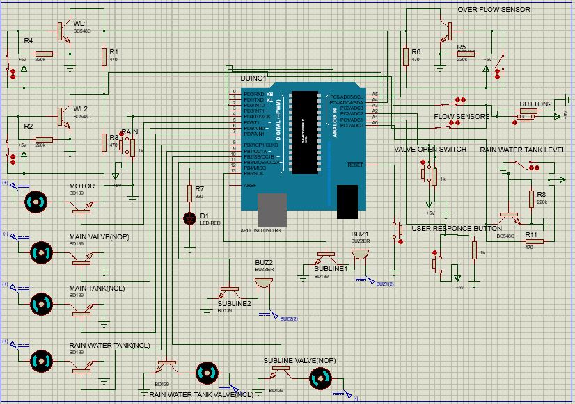

Fig 6.1 Proteus simulation

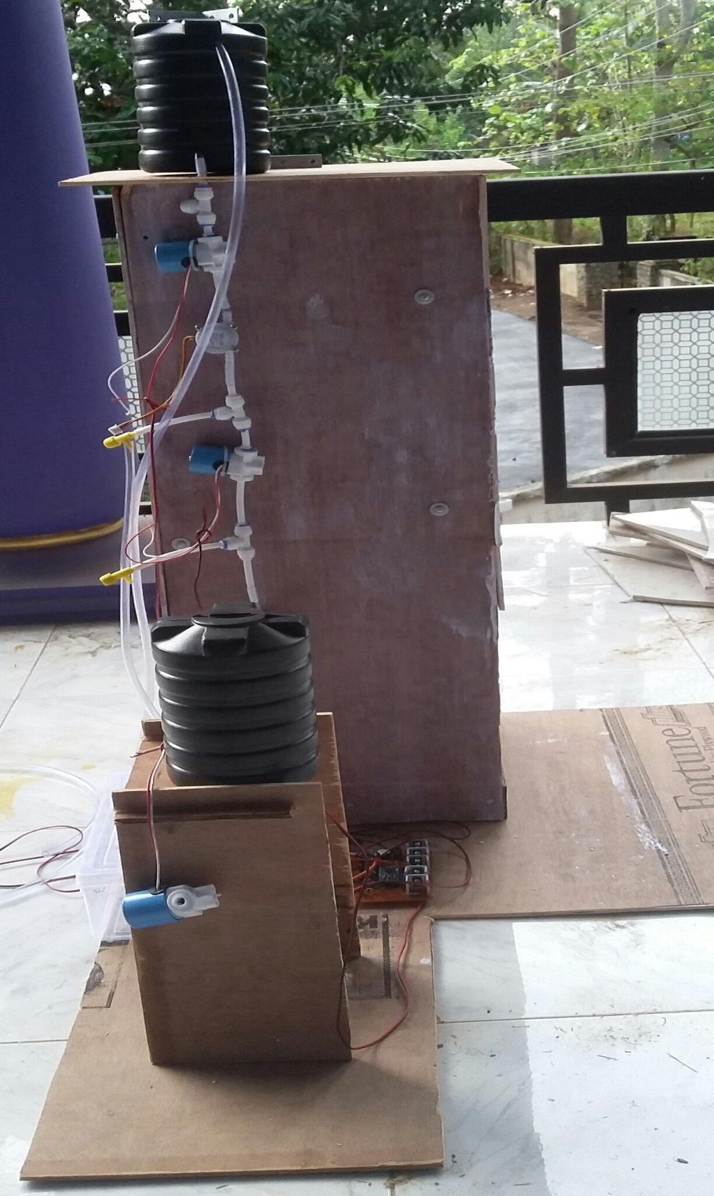

Fig 6.2 System hardware

**7.CONCLUSION**

By developing our intelligent water management system, the water problems can be easily solved. The system is able conserve water through rain water harvesting and can manage it very well for irrigation and day to day use in each household of an apartment building or similar infrastructure. The water conservation and water management system ensures that the water for future generations are conserved and this is the first step towards sustainable development. The system is highly scalable and can serve all water management purposes. In a world where technological development keeps destroying the environment, this is a step in the opposite direction where technology is used to protect the environment. Environment conservation and technological development must go hand in hand to ensure the future of life on Earth.

**REFERENCES**

[1].http://www.undp.org/content/undp/en/home/ourwork/environmentandenergy/focus_areas/water_and_ocean_governance/water-supply-and-sanitation.html

[2]. http://www.flologic.com/

[3]. https://leaksmart.com/

[4].http://www.waterguard.co.uk/wp-content/uploads/2015/04/Waterguard-Home-

Technical-Specification2.pdf

[5]. http://www.floodmaster.com/

[6]. http://www.vguard.in/

[7]. https://www.labcenter.com/

[8]. https://www.arduino.cc/en/guide/environment

[9]. Electronics for you magazine 2014 September Edition

[10].Neil Storey,Edward Hughes, Wayne Tomasi,||Basic Of Electrical, Electronics and Communication Engineering

**APPENDIX 1**

**PROGRAM**

int level1=0,level2=0;

int rw=0,rc=0,rn=0,t=0,lm=0;

const int mv=6,sv=10,led=12,buz=11,wl1=A4,wl2=A3;

int fsd=0,bh=0,button=A2,br=0;

const int rwm=7,rwt=8;

int rwtl=A0;

int rwtd=0,irr=0;

long f=0;

int of=A5,ur=A1;

int buz2=13,urd=0;

int ofd=0,b2=0,svt=0,buzs=0;

long int ofc=0,ftt=0;

const int rain=4,rv=9;

const int motor=5;

int sensorInterrupt1 = 1; // interrupt 1

int sensorInterrupt2 = 0;

const int sensorPin1 = 3; //Digital Pin 2

const int sensorPin2 = 2;

unsigned long SetPoint = 5000; //400 milileter

/*The hall-effect flow sensor outputs pulses per second per litre/minute of flow.*/

float calibrationFactor = 4.5; //You can change according to your datasheet

volatile byte pulseCount1 =0;

volatile byte pulseCount2 =0;

float flowRate1 = 0.0;

float flowRate2 = 0.0;

unsigned int flowMilliLitres1 =0;

unsigned long totalMilliLitres1 = 0;

unsigned long oldTime = 0;

unsigned int flowMilliLitres2 =0;

unsigned long totalMilliLitres2 = 0;

unsigned long oldTime1 = 0;

unsigned long oldTime3 = 0,raintime=0,urtime=0;

void setup()

{

Serial.begin(9600);

pinMode(motor,OUTPUT);

pinMode(rain,INPUT);

pinMode(rv,OUTPUT);

pinMode(mv,OUTPUT);

pinMode(sv,OUTPUT);

pinMode(led,OUTPUT);

pinMode(buz,OUTPUT);

pinMode(rwm,OUTPUT);

pinMode(rwt,OUTPUT);

pinMode(buz2,OUTPUT);

digitalWrite(sv,HIGH);

digitalWrite(mv,HIGH);

Serial.begin(9600);

pinMode(sensorPin1, INPUT);

digitalWrite(sensorPin1, HIGH);

pinMode(sensorPin2, INPUT);

digitalWrite(sensorPin2, HIGH);

/*The Hall-effect sensor is connected to pin 2 which uses interrupt 0. Configured to trigger on a FALLING state change (transition from HIGH (state to LOW state)*/

attachInterrupt(sensorInterrupt1, pulseCounter1, FALLING); //you can use Rising or Falling

attachInterrupt(sensorInterrupt2, pulseCounter2, FALLING);

}

void loop()

{

level1=analogRead(wl1);

level2=analogRead(wl2);

rw=digitalRead(rain);

t=millis();

br=analogRead(button);

ofd=analogRead(of);

urd=analogRead(ur);

if(ofd<500)

{

ofc=ofc+1;

delay(5);

}

//tank level maintaining

if(level1>500)

{

digitalWrite(motor,HIGH);

}

if(level2<500)

{

digitalWrite(motor,LOW);

}

//Rain water harvesting

if((rw==HIGH)&&(rn==0))

{

rc=rc+1;

lm=0;

if(rc==3000)

{

delay(5000);

rn=1;

digitalWrite(rv,HIGH);

}

}

if((rw==LOW)&&(lm==0))

{

if(rc>0)

rc=rc-1;

if((rc<=0))

{

delay(5000);

digitalWrite(rv,LOW);

lm=1;

}

}

if((rw==HIGH)&&(rn==1))

{

rc=rc+1;

lm=0;

if(rc>=10000)

{

digitalWrite(rv,HIGH);

}

}

//Water usage and leakage

if((millis() - oldTime) > 1000) // Only process counters once per second

{

// Disable the interrupt while calculating flow rate and sending the value to the host // Because this loop may not complete in exactly 1 second intervals we calculate the number of milliseconds that have passed since the last execution and use that to scale the output. We also apply the calibrationFactor to scale the output based on the number of pulses per second per units of measure (litres/minute in this case) coming from the sensor.

flowRate1 = ((1000.0 / (millis() - oldTime)) * pulseCount1) / calibrationFactor; // Note the time this processing pass was executed. Note that because we've

// disabled interrupts the millis() function won't actually be incrementing right

// at this point, but it will still return the value it was set to just before

// interrupts went away.

oldTime = millis(); // Divide the flow rate in litres/minute by 60 to determine how many litres have

// passed through the sensor in this 1 second interval, then multiply by 1000 to

// convert to millilitres.

flowMilliLitres1 = (flowRate1 / 60) * 1000; // Add the millilitres passed in this second to the cumulative total

totalMilliLitres1 += flowMilliLitres1;

unsigned int frac; // Print the flow rate for this second inlitres / minute

Serial.print(totalMilliLitres1,DEC);

Serial.println("mL");

Serial.print("\t");

}

if((millis() - oldTime1) > 1000) // Only process counters once per second

{

flowRate2 = ((1000.0 / (millis() - oldTime1)) * pulseCount2) / calibrationFactor; // Note the time this processing pass was executed. Note that because we've

// interrupts went away.

oldTime1 = millis(); // Divide the flow rate in litres/minute by 60 to determine how many litres have

// passed through the sensor in this 1 second interval, then multiply by 1000 to

// convert to millilitres.

flowMilliLitres2 = (flowRate2 / 60) * 1000; // Add the millilitres passed in this second to the cumulative total

totalMilliLitres2 += flowMilliLitres2;

unsigned int frac;

if(((millis()-oldTime3)>5000)&&(flowMilliLitres2>10))

{

totalMilliLitres2=totalMilliLitres1;

oldTime3=millis();

}

Serial.print(totalMilliLitres2,DEC);

Serial.println("mL");

Serial.print("\t");

if (totalMilliLitres2 > 5000)

{ SetSolinoidValve(); }// Reset the pulse counter so we can start incrementing again

pulseCount2 = 0;

pulseCount1=0;// Enable the interrupt again now that we've finished sending output attachInterrupt(sensorInterrupt, pulseCounter, FALLING);

}

fsd=totalMilliLitres1-totalMilliLitres2; //Leakage

if((fsd>5000)&&(svt==0))

{

analogWrite(sv,0);

digitalWrite(led,HIGH);

svt=1;

}

if(((flowMilliLitres1)>0)&&(svt==1))

{

digitalWrite(sv,HIGH);

digitalWrite(mv,LOW);

digitalWrite(buz,HIGH);

}

br=analogRead(button);

if((br>100))

{

digitalWrite(sv,HIGH);

digitalWrite(led,LOW);

digitalWrite(mv,HIGH);

digitalWrite(buz,LOW);

svt=0;

totalMilliLitres1=totalMilliLitres2;

}

// Irrigation

t=millis();

f=t/1000;

if((f>3)&&(rn!=1)&&(irr==0))

{

raintime=millis();

rwtd=analogRead(rwtl);

if((rwtd<500)&&(irr==0))

{

digitalWrite(rwt,HIGH);

irr=1;

}

if((rwtd>500)&&(irr==0))

{

digitalWrite(rwm,HIGH);

irr=1;

}

}

if(((millis()-raintime)>5000)&&(irr=1));

{

digitalWrite(rwt,LOW);

digitalWrite(rwm,LOW);

raintime=0;

}

t=millis();

f=t/1000;

if(f>=300000)

{

irr=0;

}

if(f>=60000)

{

rn=0;

}

if((ofc>10)&&(buzs==0)&&(b2==0))

{

digitalWrite(buz2,HIGH);

b2=1;

}

urd=analogRead(ur);

if((urd>500)&&(b2==1))

{

digitalWrite(buz2,LOW);

ofc=0;

buzs=1;

b2=0;

urtime=millis();

}

if((ofc>1000)&&(buzs==0)&&((millis()-urtime)>5000))

{

digitalWrite(sv,LOW);

ofc=0;

}

}

void pulseCounter1()

{

// Increment the pulse counter

pulseCount1++; }

void pulseCounter2()

{

// Increment the pulse counter

pulseCount2++; }

void SetSolinoidValve()

{ digitalWrite(sv, LOW);

}

**APPENDIX-II**

**DATA SHEETS**